# Scenario #3: Exit Car Park

## Scenario Description

* The customer wants to exit the car park, so they interact with the exit control pillar to be able to exit the car park.
* The customer can be either an adhoc ticket holder or a season ticket holder.

## Version Control

|  |  |  |  |
| --- | --- | --- | --- |
| Version # | Date | Author | Description |
| 0.1 | 22/09/2017 | Wayne Barlow | Initial Draft |
| 1.0 | 01/10/2006 | Author Name | Initial Version |

## Test Scripts

The following scripts will cover this scenario:

* 3.1 Adhoc Ticket Customer: Ticket Paid
* 3.2 Season Ticket Customer: Valid Ticket
* 3.3 Adhoc Ticket Customer: Ticket Unpaid
* 3.4 Season Ticket Customer: Ticket Not Valid
* 3.5 Customer Backs Up

## Use Case

* This test scenario covers the use case: Exit Car Park

## Test Components/Requirements

This test scenario covers the following high-level test requirements (see scripts below for specific requirements covered by each test script):

* The car park is open for business and all components (gates, pillars, etc.) are online and ready for operation.
* A customer is ready to leave the carpark and has a ticket, either adhoc or season.

## User Groups

* Customers with adhoc tickets
* Customers with season tickets

## Script #3.1: Adhoc Ticket Customer: Ticket Paid

### Script Description

* The customer inserts an adhoc ticket in the exit pillar, the system displays a message to the customer, ejects the ticket and the customer takes the ticket, the exit barrier is raised and the customer exits the car park.

### Testing Requirements

This test script covers the following specific testing requirements:

* Customer must be an adhoc ticket holder and the ticket must have been paid at the paystation and it must be no more than 15 minutes after the time the ticket was paid.

### Setup

* An adhoc ticket has been issued and recorded in the system.
* The adhoc ticket is for this car park.
* The adhoc ticket has been paid.
* The adhoc ticket has a valid time (no more than 15 minutes from payment time.

### Teardown

* The adhoc ticket is no longer valid.

### Script Steps

| **Step #** | **Test Action** | **Expected Results** | **Pass/ Fail** |
| --- | --- | --- | --- |
| 1 | Customer inserts ticket | Exit pillar displays ‘Take Ticket’ message  Exit pillar ejects ticket | F |
| 2 | Customer takes ticket | Exit barrier raises | N/A |
| 3 | Customer exits car park | Exit barrier lowers | N/A |

### Test Execution

|  |  |  |  |  |
| --- | --- | --- | --- | --- |
| Date/Time | Tester | Test ID | Test Phase | Status |
| 22/09/17 | Wayne Barlow |  |  | Failed |
|  |  |  |  |  |

### Debugging Notes

|  |  |  |
| --- | --- | --- |
| Step # | Input Data | Details of test results |
| 1 | Adhoc Ticket A3119092017091453 | Execution stops with a NullPointerException in the Exit User Interface module (ExitUI) line 142 in the readTicket method. See screenshot below. Steps 2 and 3 cannot be performed. |

### Screen Shots

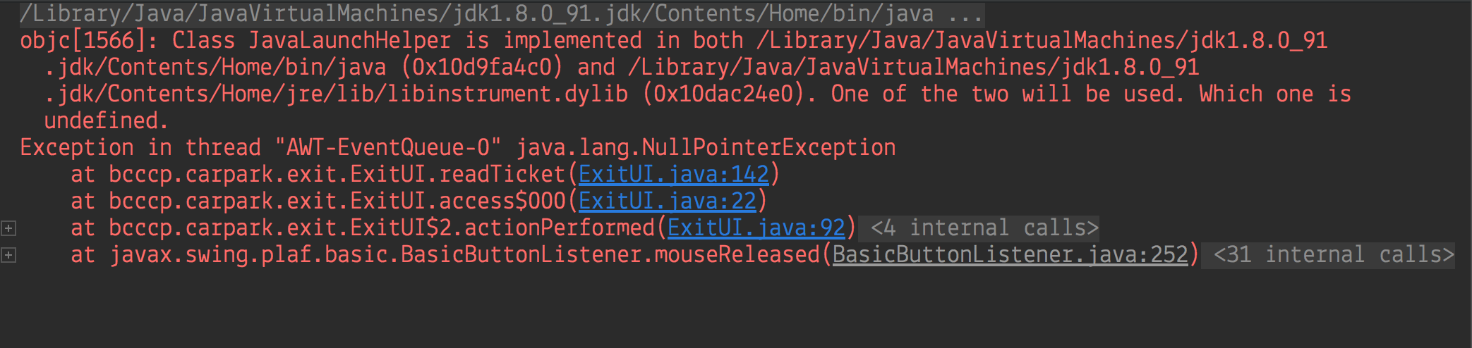

## Script #3.2: Season Ticket Customer: Valid Ticket

### Script Description

* The customer inserts a season ticket in the exit pillar, the system displays a message to the customer, ejects the ticket and the customer takes the ticket, the exit barrier is raised and the customer exits the car park.

### Testing Requirements

This test script covers the following specific testing requirements:

* Customer must be a season ticket holder and the ticket must be valid and in use.

### Setup

* A season ticket has been issued and recorded in the system.
* The season ticket is for this car park.
* The season ticket is valid.
* The season ticket is in use.

### Teardown

* The season ticket usage record is closed for this usage.

### Script Steps

| **Step #** | **Test Action** | **Expected Results** | **Pass/ Fail** |
| --- | --- | --- | --- |
| 1 | Customer inserts ticket | Exit pillar displays ‘Take Ticket’ message  Exit pillar ejects ticket | F |
| 2 | Customer takes ticket | Exit barrier raises | N/A |
| 3 | Customer exits car park | Exit barrier lowers | N/A |

### Test Execution

|  |  |  |  |  |
| --- | --- | --- | --- | --- |
| Date/Time | Tester | Test ID | Test Phase | Status |
| 22/09/17 | Wayne Barlow |  |  | Failed |

### Debugging Notes

|  |  |  |
| --- | --- | --- |
| Step # | Input Data | Details of test results |
|  | Season Ticket S3220092017113517 | Execution stops with a NullPointerException in the Exit User Interface module (ExitUI) line 142 in the readTicket method. See screenshot below. Steps 2 and 3 cannot be performed. |

### Screen Shots

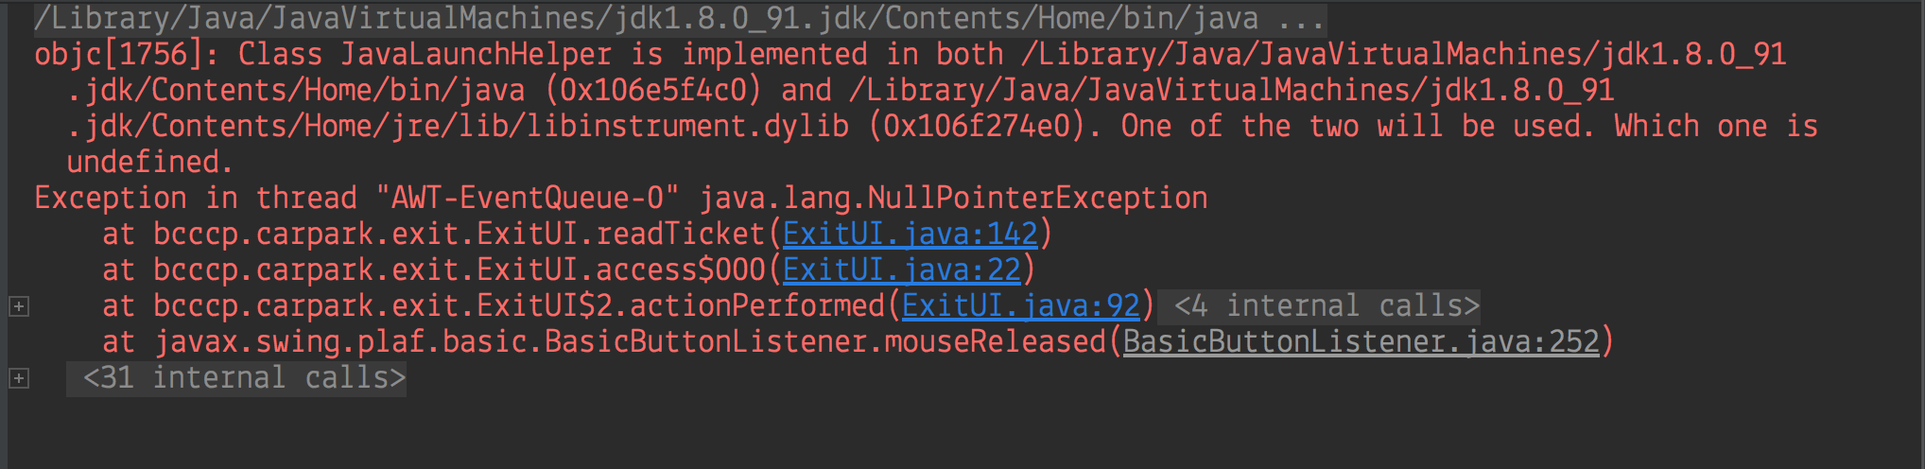

## Script #3.3: Adhoc Ticket Customer: Ticket Unpaid

### Script Description

* The customer inserts an invalid adhoc ticket in the exit pillar, the system displays a message ‘Invalid Ticket’ to the customer, then ‘Remove Invalid Ticket’, ejects the ticket and the customer takes the ticket and the exit pillar displays ‘Insert Ticket’.

### Testing Requirements

This test script covers the following specific testing requirements:

* Customer must be an adhoc ticket holder and the ticket must be invalid because it has not been paid at the paystation.

### Setup

* An adhoc ticket has been issued and recorded in the system.
* The adhoc ticket is for this car park.
* The adhoc ticket has NOT been paid.

### Teardown

* The adhoc ticket is no longer available.

### Script Steps

| **Step #** | **Test Action** | **Expected Results** | **Pass/ Fail** |
| --- | --- | --- | --- |
| 1 | Customer inserts invalid ticket | Exit pillar displays ‘Invalid Ticket’ message  Exit pillar displays ‘Remove Invalid Ticket’ | F |
| 2 | Customer takes ticket | Exit pillar displays ‘Insert Ticket’ | N/A |

### Test Execution

|  |  |  |  |  |
| --- | --- | --- | --- | --- |
| Date/Time | Tester | Test ID | Test Phase | Status |
| 22/09/17 | Wayne Barlow |  |  | Failed |
|  |  |  |  |  |

### Debugging Notes

|  |  |  |
| --- | --- | --- |
| Step # | Input Data | Details of test results |
|  | Adhoc Ticket A5670002018132516 | Execution stops with a NullPointerException in the Exit User Interface module (ExitUI) line 142 in the readTicket method. See screenshot below. Step 2 cannot be performed. |

### Screen Shots

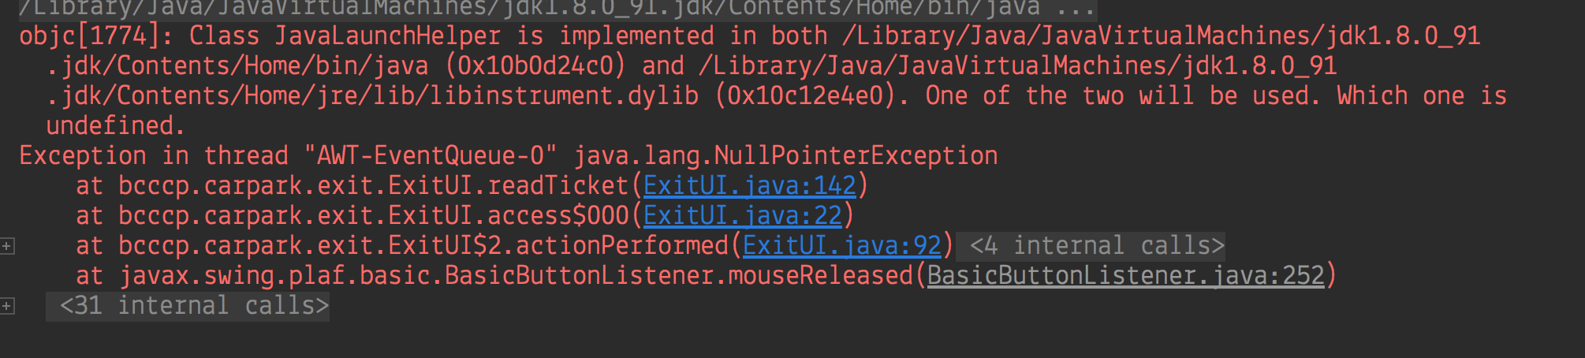

## Script #3.4: Season Ticket Customer: Ticket Not Valid

### Script Description

* The customer inserts an invalid season ticket in the exit pillar, the system displays a message ‘Invalid Ticket’ to the customer, then ‘Remove Invalid Ticket’, ejects the ticket and the customer takes the ticket and the exit pillar displays ‘Insert Ticket’.

### Testing Requirements

This test script covers the following specific testing requirements:

* Customer must be a season ticket holder and the ticket must be NOT valid.

### Setup

* A season ticket has been issued and recorded in the system.
* The season ticket is for this car park.
* The season ticket is NOT valid.

### Teardown

* The season ticket is no longer available.

### Script Steps

| **Step #** | **Test Action** | **Expected Results** | **Pass/ Fail** |
| --- | --- | --- | --- |
| 1 | Customer inserts invalid ticket | Exit pillar displays ‘Invalid Ticket’ message  Exit pillar displays ‘Remove Invalid Ticket’ | F |
| 2 | Customer takes ticket | Exit pillar displays ‘Insert Ticket’ | N/A |

### Test Execution

|  |  |  |  |  |
| --- | --- | --- | --- | --- |
| Date/Time | Tester | Test ID | Test Phase | Status |
| 22/09/17 | Wayne Barlow |  |  | Failed |
|  |  |  |  |  |

### Debugging Notes

|  |  |  |
| --- | --- | --- |
| Step # | Input Data | Details of test results |
|  | Season Ticket S0000002017012200 | Execution stops with a NullPointerException in the Exit User Interface module (ExitUI) line 142 in the readTicket method. See screenshot below. Steps 2 cannot be performed. |

### Screen Shots

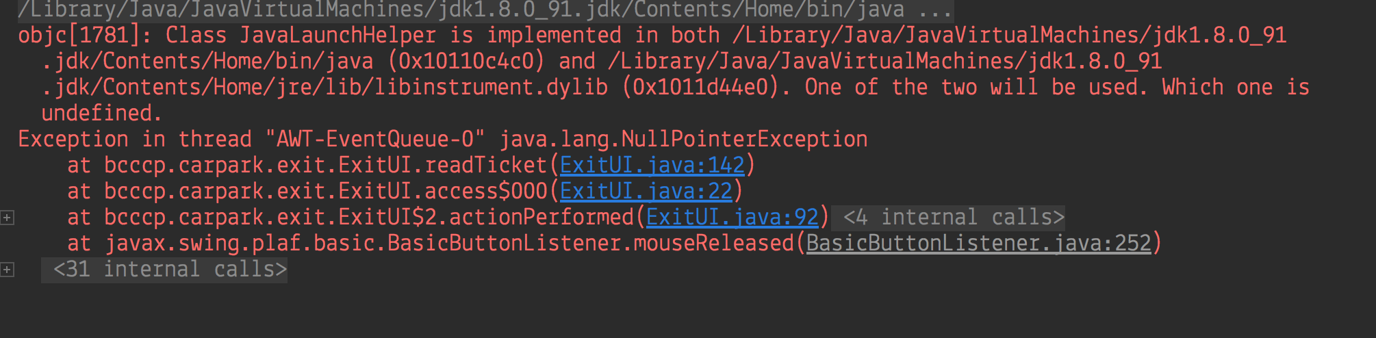

## Script #3.5: Customer Backs Up

### Script Description

* The system detects there is no car at the exit pillar at any stage of the customer exit process prior to the customer exiting the car park.

### Testing Requirements

This test script covers the following specific testing requirements:

* The customer has a valid adhoc or season ticket.

### Setup

* A ticket (either adhoc or season) has been issued and recorded in the system.
* The ticket is for this car park.
* The ticket is valid.
* If a season ticket, it is in use.
* If an adhoc ticket, it has been paid and the current time is no more than 15 minutes from payment.

### Teardown

* No teardown steps applicable.

### Script Steps

| **Step #** | **Test Action** | **Expected Results** | **Pass/ Fail** |
| --- | --- | --- | --- |
| 1 | Customer backs up car | Exit pillar resets to display ‘Insert Ticket’ | Fail |

### Test Execution

|  |  |  |  |  |
| --- | --- | --- | --- | --- |
| Date/Time | Tester | Test ID | Test Phase | Status |
|  |  |  |  |  |
|  |  |  |  |  |

### Debugging Notes

|  |  |  |
| --- | --- | --- |
| Step # | Input Data | Details of test results |
|  |  | This cannot be tested with the current system configuration. This would require the inside sensor of the exit pillar to be triggered and then detect no car present. The current system has no means for activating this event. |

### Screen Shots